### **Programming Assignment**

Using the relations that you have defined for the library system, normalize your relations into first, second, and third normal form. Your output should be an Entity Relationship diagram that is in 3NF. All attributes, entities, keys, and relationships should be included and labeled. Although you do not need to include an ER diagram (unless you want to) for the relations in 1st normal form or 2nd normal form, you must describe the changes required to your relations to meet the standard of first 1st normal form and then 2nd normal form and of course 3rd normal form.

**Assignment Instructions:**

* the assignment must define or describe the changes required to get the relations into the 1st normal form
* the assignment must define or describe the changes required to get the relations into the 2nd normal form
* the assignment should include an Entity Relationship diagram that details each of the following relations and their attributes in 3rd normal form.
  + Book
  + Borrower
  + BookLended
  + Librarian
* the primary and foreign keys, at a minimum are defined for each relation in the ER diagram
* the assignment should include an Entity Relationship diagram that details the relationships between Relations. Be sure to copy and paste this diagram into your assignment,

**Original Diagram:**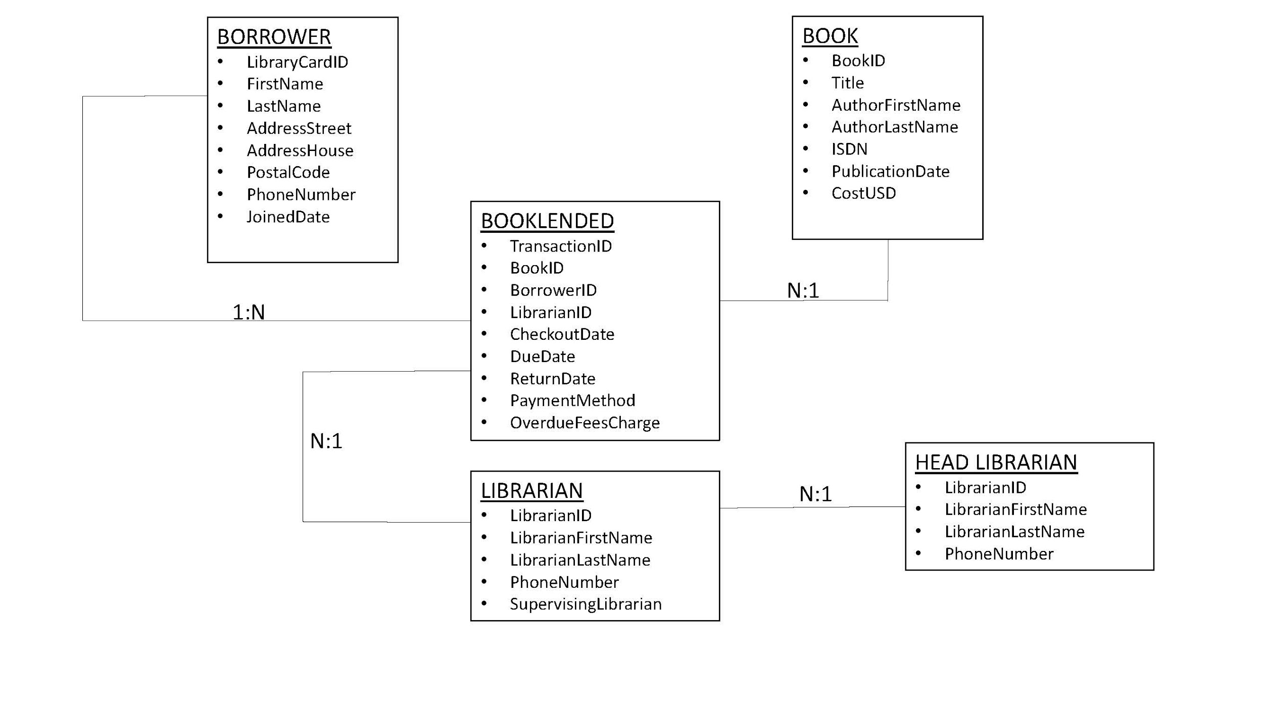

So we have these four tables / relations below. I have bolded attributes that could be duplicated / not atomic.

|  |  |  |  |
| --- | --- | --- | --- |
| **BORROWER** | **BOOKLENDED** | **LIBRARIAN** | **BOOK** |
| LibraryCardID | TransID (P) | LibrarianID (P) | BookID (P) |
| firstName | ISBN (F) | LibrarianFName | Title |
| lastName | BorrowerID (F) | LibrarianLName | AuthorFName |
| Address | LibrarianID (F) | PhoneNumber | AuthorLName |
| PostalCode | CheckoutDate |  | ISDN (P) |
| PhoneNumber | ReturnDate |  | PubDate |
| JoinedDate | PaymentMethod |  | CostUSD |
|  | OverdueFees |  |  |
|  |  |  |  |

* It is unlikely for anything in Borrower relation to repeat or be ordinal. JoinedDate could conceivable be the same for multiple individuals. However it doesn’t seem to warrant separation.
* In BookLended, Payment Method could easily repeat, along with BookID, BorrowerID, LibrarianID. We can separate these out.
* Librarian Looks alright.
* BookID cannot repeat. Author Names could repeat. Title could repeate if there are multiple copies of a book as with ISDN. Books could be published on the same date and have the same cost.

|  |  |  |  |
| --- | --- | --- | --- |
| **BORROWER** | **BOOKLENDED1** | **LIBRARIAN** | **BOOK** |
| LibraryCardID (P) | TransID (P) | LibrarianID (P) | ISBN (P) |
| firstName | LibraryCardID (F) | LibrarianFName | Title |
| lastName | CheckoutDate | LibrarianLName | AuthorFName |
| Address | ReturnDate | PhoneNumber | AuthorLName |
| PostalCode | OverdueFees |  | PubDate |
| PhoneNumber |  |  | CostUSD |
| JoinedDate | **BOOKLENDED2** |  |  |
|  | TransID (P) |  |  |
|  | Payment Method |  |  |
|  |  |  |  |
|  |  |  |  |
|  |  |  |  |

2nd NF: The rule of the 2nd normal form says that every attribute of a relation depends on the entire key not on part of it. So we will have to check to ensure that each attribute is fully dependent on the primary and foreign keys.

* Borrower ID looks okay.
* For Booklended, everything depends on only the PK. In fact, our relations are setup in such a way that they all have single primary keys, so we are okay by 2nd NF.

3rd NF: Removing transitive dependencies.

* Main one here is in Book relation: Author name(s), PubDate, Cost, all depend on the Book Title, which indirectly depends on ISBN. Lets separate

|  |  |  |  |
| --- | --- | --- | --- |
| **BORROWER** | **BOOKLENDED1** | **LIBRARIAN** | **BOOK1** |
| LibraryCardID (P) | TransID (P) | LibrarianID (P) | ISBN (P) |
| firstName | LibraryCardID (F) | LibrarianFName | Title (F) |
| lastName | CheckoutDate | LibrarianLName |  |
| Address | ReturnDate | PhoneNumber | **BOOK2** |
| PostalCode | OverdueFees |  | Title (P) |
| PhoneNumber |  |  | AuthorFName |
| JoinedDate | **BOOKLENDED2** |  | AuthorLName |
|  | TransID (P) |  | PubDate |
|  | Payment Method |  | CostUSD |
|  |  |  |  |
|  |  |  |  |
|  |  |  |  |

And so this would be our final relations in the above chart.